 **Salem Amera** 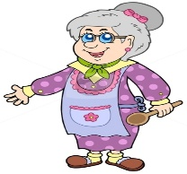

Maisoon Mohamed 

 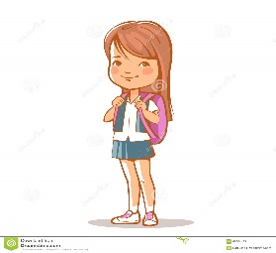

Majd Sally

1. What is the name of the grandfather? ___________________
2. What is the name of the sister ? _______________________
3. What is the name of the father? _______________________
4. What is the name of the grandma?______________________
5. What is the name of the brother?_______________________
6. What is the name of the mother? _______________________